IEEE MEMS 2023 CONFERENCE SAMPLE ABSTRACT

AND INSTRUCTIONS FOR ABSTRACT PREPARATION

REMEMBER THAT NO NAME OF AUTHORS AND/OR INSTITUTIONS SHOULD APPEAR ON THIS ABSTRACT, AS IT IS PREPARED FOR A DOUBLE-BLIND REVIEW (DBR) PROCESS!

**Novelty / Progress Claim(s)**

**Write here, in bold, your specific qualitative and/or quantitative novelty claim(s): what you have achieved for the first time, and/or how your work advances the state of research in the field. For example: “This paper reports a miniaturized electrochemical sensor with a three-fold reduction in cross-sensitivity compared to state of the art, which will allow, for the first time, minimally invasive *in-vivo* detection of biomarkers.” Work that is not original or that has been presented in other international conferences elsewhere will not be accepted unless considerable progress has been achieved.**

Background / State of the Art

It is also important to identify how the new work differs from previous work of your own group and of other groups, especially work presented at recent and upcoming international meetings. For example: “The work builds on a fabrication process reported at MEMS 2022 [1]. The electrode design and their performance analysis have been accepted for publication elsewhere [2,3]. This paper will show a complete set of experimental results on five device geometries and will also report on simulations which provide design guidelines for adapting this method to other types of gyroscopes. The method reported here differs from previous work [4] in the specific method of temperature compensation and in the geometry of the electrodes and their placement within the structure.”

Description of the New Method or System

Introduce the basic ideas and present detailed descriptions of methods and device structures.

Experimental Results

Clearly outline the specific results, whether experimental or theoretical. Make sure that every novelty claim, in bold above, is supported by appropriate theoretical or experimental results. Reviewers will mainly judge your abstract based on how the experimental/theoretical results support the novelty claims.These results can be supported by figures and/or tables on page two of the abstract. For example: “A schematic view of the gyroscope is shown in Figure 1, with a close-up detail of the electrode geometry and placement in Figure 2. The fabrication process is schematically shown in Figures 3. Table 1 shows the ratio of cross-sensitivities to in-plane yaw for a set of five devices fabricated with different overall geometries and sensitivities. Also shown in Table 1 are the simulation results for these specific device geometries using the analysis procedure in [2].” After presentation of results, it is useful to compare specific results with related work, to discuss possible discrepancies or agreement, and also to comment on the broader impact of the results.

Word count: 390

References

[1] S. Ample, Proc. MEMS 2022, pp. 100-103.

[2] A. B. Stract and S. Ample, Tech. Digest IEDM 2019, pp. 200-205.

[3] S. Mart and S. O. Lution, J. Microelectromech. Syst, 23 (2017), pp. 300-315.

[4] B. Etter and A. P. Proach, The Biosensor Handbook, 2nd ed. (Singer, 2016), pp. 400-401



Figure 2: Spectral content of diffracted light from a programmed grating for single (upper) and double (lower) band pass filters. The dashed lines are the simulated spectra while the solid lines are the measured spectra.

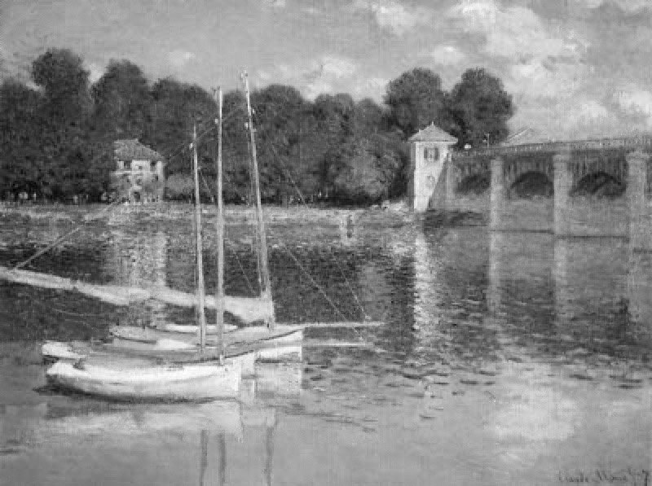

Figure 1: Reflections on corrugated liquid/gas interface, with obstacles, observed by Monet. Rendering with 300 dpi

Table 1. Sample of a Table format.

|  |  |  |  |
| --- | --- | --- | --- |
| Table head | Table column head | | |
| Table column subhead | Subhead | Subhead |
| Copy | More table copy |  |  |



Figure 3: View of xxxxxxxxxxxxxxxxxx.



Figure 4: SEM of xxxxxxxx.